Legend says that the Image of Our Lady of Good Counsel originally appeared in Albania in the 1200s, at a time when several Albanian provinces were converted to Catholicism. The painter was never identified and tradition held that the image was brought from the East by angelic hands on the same occasion that the House of the Holy Family was miraculously translated from Nazareth to Loreto in Italy. The image was originally venerated under many titles, including Our Lady of Good Offices and the Virgin of Scutari.

The Miraculous Image of Our Lady, Mother of Good Counsel
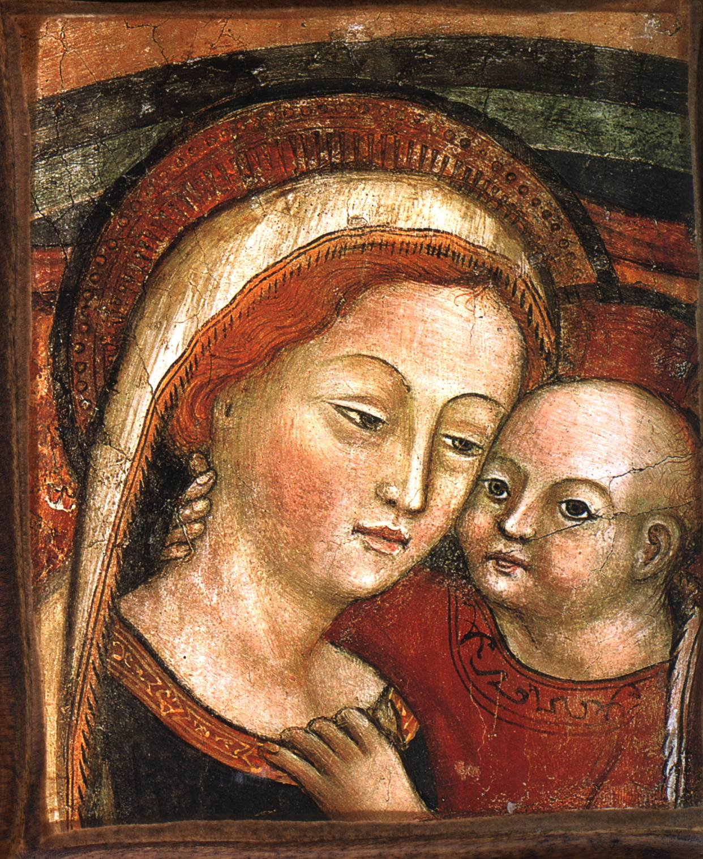

Our Lady leaves unfaithful Albania
In the 1460s, the true faith had begun to dwindle in Albania. The Turks, the great Moslem enemy of Albania, invaded. Two Albanian men, believing that the Virgin of Scutari had been the patron, who had given victory to the faithful against the Turks in the past, went to pray for her help. The men could not decide whether to leave their country forever, or stay and fall under Mohammedan rule. At the shrine of the Blessed Virgin they began to pray for her guidance. That night they both dreamt that the Virgin appeared to them, telling them that she herself would leave the unfaithful Scutari and that they were to follow her. When they awoke, they decided to go and pray before the image. While they were at prayer, the painting detached itself from the wall and was enveloped in a luminous white cloud. It left the church and began to move away, carried by unseen angels. The two men followed faithfully, and when the painting reached the Adriatic Sea they found themselves able to walk on the surface of the sea to fulfil the Blessed Virgin's command. They were neither tired nor hungry while they followed her and they arrived safely in Italy. When they reached Rome however, and the painting suddenly disappeared, they were disconsolate. They soon began visiting each church they came across in the hope of finding the place where the Virgin of Scutari had chosen to rest.

A pious soul merits Our Lady’s notice
Meanwhile in the small town of Genazzano, where Pope St Mark (Pope from Jan - Oct 336) had built the first church dedicated to Our Lady of Good Counsel, a widow Petruccia de Nocera had devoted herself to the Mother of Good Counsel. Petruccia, a member of the third order of St Augustine, burned with zeal for the spread of the true faith, and for the reawakening of the faith of the lapsed. One day as she prayed, the Holy Ghost made her aware that the Blessed Virgin in her image in Scutari wished to leave Albania to come to rest in the Church in Genazzano. Our Lady then ordered the widow to rebuild the chapel that would shelter her image. Despite the ridicule of her neighbours, Petruccia set to work eagerly, only to run out of money soon after the work was begun. The scorn of the locals increased, but Petruccia answered only that 'the Blessed Virgin and St Augustine, would complete the church’.

On the 25th April 1467, feast of St Mark, Genazzano's patron, and the anniversary of the baptism of St Augustine, a fair was held in the town. At about 4pm, celestial music attracted the attention of the people. Suddenly a beautiful white cloud appeared and descended gradually until it came to rest on one of the walls of the unfinished chapel. Every church bell in the town began to ring in harmony. The cloud disappeared revealing the beautiful fresco of Our Lady, which then became known as Our Lady of Good Counsel. The townspeople cried out "Evviva Maria, Evviva Maria, Evviva la Madre nostra del Buon Consiglio". On that day the sick, the blind and the lame from all around were cured and many graces were given to the people. The two Albanian soldiers, still in Rome heard of the miraculous apparition in Genazzano. Joining a Pilgrimage to that town, they were overjoyed to find the image, which they knew as Our Lady of Scutari, and they told the town's inhabitants their story. The men settled in Genazzano. Donations flooded in for the church to be built and a new Friary for the Augustinian Friars was also established. Petruccia lived to see the church completed and then passed away in 1470. Her remains were laid to rest in the church, and from that time she was venerated as Blessed.

The Image remained suspended in that church and later in the shrine built to replace it in the 1620s, without any visible means of support, for 500 years. Such was the reward for the heroic faith and virtue of Petruccia.

Our Lady still cares for Scutari
As for Scutari, Our Lady did not abandon it completely, remembering that for two centuries the Albanians had honoured her there. The Turks captured the city in January 1479, but miracles surrounded the little Church of the Annunciation where the image once lay. No attempt to turn the Church into a Mosque succeeded, for whatever was built in the daytime collapsed at night. Wind and lightning arose to destroy the attempts of those who tried to call the Turks to pray there. Every year on the feast of the Annunciation, a votive candle would be seen burning in front of the abandoned altar. Eventually, fearing to touch the remains of the Church, the Turks left it alone. It was only in the 1920’s that the Church was destroyed and a new Church put in its place. However, in 1944 a Communist dictatorship was established in Albania. The Shrine was converted into a restaurant and dance hall. Then in 1967, five hundred years after the miraculous transfer of Our Lady of Good Counsel to Italy, the Red Guards destroyed the church completely. That same year Envere Hodsha proudly proclaimed Albania ’the first Atheist State in the world’. Despite persecution Albania’s faithful continue to go to the place where the Church of Our Lady of Good Counsel stood, praying 'Return quickly, O gracious Mother, return quickly to Albania’. Tradition
suggests that Our Lady’s Image will return to Scutari when Albania is Catholic again.

The Mother of Good Counsel is honoured by Popes and Saints
At her Shrine in Genazzano, Our Lady’s intercession has brought about many cures, conversions and miracles. Many members of the hierarchy, including many Sovereign Pontiffs have had a great devotion to her. The list is too long to document here, but it includes:
- Pope Alexander VI granted the special privilege of freeing a soul from Purgatory each time Holy Mass was celebrated on Our Lady’s altar at Genazzano.
- Pope Innocent XI ordered that the image be crowned.
- Pope Pius VI approved a proper Mass and Office for the feast of Our Lady of Good Counsel (April 25) for Genazzano, this celebration spread to other dioceses where it is celebrated on April 26.
- Pope Pius IX erected an Altar to Our Lady of Good Counsel in the Vatican Palace.
- Monsignor Merry del Val testified how Cardinal Sarto (Pope St Pius X) spent many hours before that Altar before accepting his election to the Papacy. As Pope he also kept a picture of the Queen of Good Counsel on his desk.
- Pius XII visited the Shrine countless times from his Seminary days onwards.
- Pope Clement XI granted to the Shrine the same privileges attached to the Shrine of the Holy House in Loreto.
- Pope Benedict XIV approved the Pious Union of Our Lady of Good Counsel, and he wanted to be the first to join it. That confraternity has been called the 'Pious Union of Popes’ because of the great number of Pontiffs who have joined it’s ranks: Pius VI, Pius VII, Pius VIII, Gregory XVI, Pius IX, Leo XIII, and, more recently, John XXIII.
- Pope Leo XIII included the invocation 'Mater Boni Consilii’ in the Litany of Loreto. He instituted the scapular of Our Lady of Good Counsel.
- Gregory XIII, Paul V, Innocent XII, Benedict XIII, Clement XII, and Pius XI approved devotion to the Mother of Good Counsel and granted special benefits to her shrine.
- Pope Urban VIII, Pope Pius IX and Pope John XXIII as well as Pope John Paul II have prayed before the Shrine of Our Lady Mother of Good Counsel in Genazzano.
- Saint Alphonsus Mary Liguori and St John Bosco are amongst many saints who exhibited a great devotion to this Image of the Blessed Virgin.

Pope John Paul II speaks about the Mother of Good Counsel

Pope John Paul II in one of his first general audiences asked ’What should the new Pope do so as to act prudently? … He should pray and try to have the gift of the Holy Ghost called the gift of counsel. Those who wish that the Pope be a prudent Pastor of the Church should implore for him the gift of counsel and should also pray for that gift for themselves through the special intercession of the Mother of Good Counsel“ (09/10/78).
Again in September 1998, the Holy Father advised the faithful to pray to Our Lady of Good Counsel to be able to understand the signs which the Holy Ghost places in our lives.

Our Lady Mother of Good Counsel and abortion
England led the way in the legalisation of the barbaric slaughter of the innocent, which we call abortion. Five hundred years after the miraculous journey of the Image of Our Lady of Good Counsel in 1467, here in England the abortion bill was being prepared. In 1967 the bill became law. The Feast of Our Lady of Good Counsel, April 26th 1968, was celebrated in a country which was about to lose its soul. What pleading prayers Our Lady must have offered to her Son that day we can only imagine, but man knew better than God and rejecting all remaining twinges of conscience, the brutal trade of mass annihilation began the next day, April 27th 1968.

The beautiful Image of Our Lady Mother of Good Counsel teaches us real maternal devotion and hope. It’s distinguishing features are the placement of the hands of the Child Jesus, one tightly around His Mother’s neck, the other firmly grasping the neck of her dress. Then there is the intense gaze, which passes between Mother and Child. The Image is an example of how tightly bound the well being of Mother and Child are, of the permanent and indissoluble bond between them. Finally the rainbow in the background, which reminds us of God’s Covenant with man, after the world had become so evil that He had punished them with the flood.

Abortions take place for many reasons and we do not have the right to judge those individuals who seek them. However, there is always an alternative to abortion, but our society is a product of the culture of death, which trains us to despair of finding a real and hopeful alternative. The Catholic Church has always taught that it is one of the Spiritual works of Mercy to ’Counsel The doubtful’. In encouraging us to fulfil this duty, Holy Mother Church asks us to use not the fruits of human knowledge or training, but the gift of Counsel bestowed upon us all by the Holy Ghost at our Confirmation. The abortion industry prides itself on the 'non-directional counselling’ which it gives to women who come seeking abortion. The just Catholic answer to this is to offer women the gift of Counsel, by putting ourselves at the disposal of Jesus and Mary and relying on the prayers of the Mother of Good Counsel.
Who better than she, the Wise Mother of Our Lord, to train us to use to its fullest extent the gift of Wise Counsel?
If people spent one hour a week in Eucharistic Adoration, abortion would be ended.

Saint Mother Theresa

